XCP-ng getting started

This month, I would like to show you how to set up you XCP-ng instance.
XCP-ng is my Hypervisor of choice, I have been using for years now at work.
This is our solution for our lab in APAC and this is a rock solid solution.
I have never experienced any issue with it except due to hardware issues which is essentially disks failing.
Few years ago it was not as intuitive as the other hypervisor to get started such as vmWare ( When it was not Qualcomm ), or Proxmox ( to be fully transparent I have not tested it yet ).
But today with the Vates team, which is the company now supporting XCP-ng and which built Xen Orchestra, it is now getting much easier to install, and maintain a single node or manage multiple nodes.

High level infra
In simple architecture for an home lab as of today you will need to install XCP-ng and then deploy Xen Orchestra ( Aka XOA ).
XCP-ng is the hypervisor which will host your Virtual machines and XOA is the layer that permits you to deploy, configure, monitor your XCP-ng hosts and Virtual machines.

Xen Orchestra comes with two versions.
XO lite which is a built-in management and deployment tool of the full fledge XOA.
XOA is the full version of the Virtual machine and XCP-ng host management tool, it is web based solution that you will have to deploy as a virtual machine in XCP-ng to start administer your XCP-ng and VMs infra.
This is not clear up what level of feature Vates itend to go to for XO lite. So far as I know the goal of this version is to provide a single node only capable solution to deploy VMs, and administer the node on which it is running on. This should be good enough for an home laber that done need to run several nodes on XCP-ng but still deploy and manage all VMs and host configuration.
That said, this is still a long way to be done. This is still a work in progress.
From my initial testing with XO lite you can only deploy XOA full version and perform only basic configuration.
You’ll find lot’s of button that don’t work and teasing a future feature, but you can’t really tell when it will happen.
With this is mind as of now the main route for now is once you have installed XCP-ng on your machine you will deploy XOA full version which can be done from XO lite directly.

Install steps

Install XCP-ng
First you need to download the ISO image
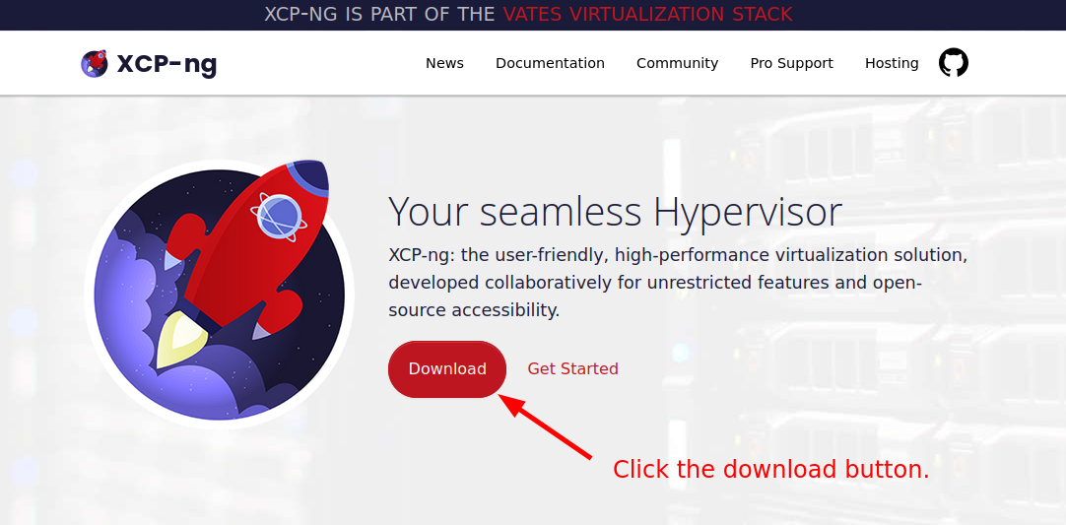
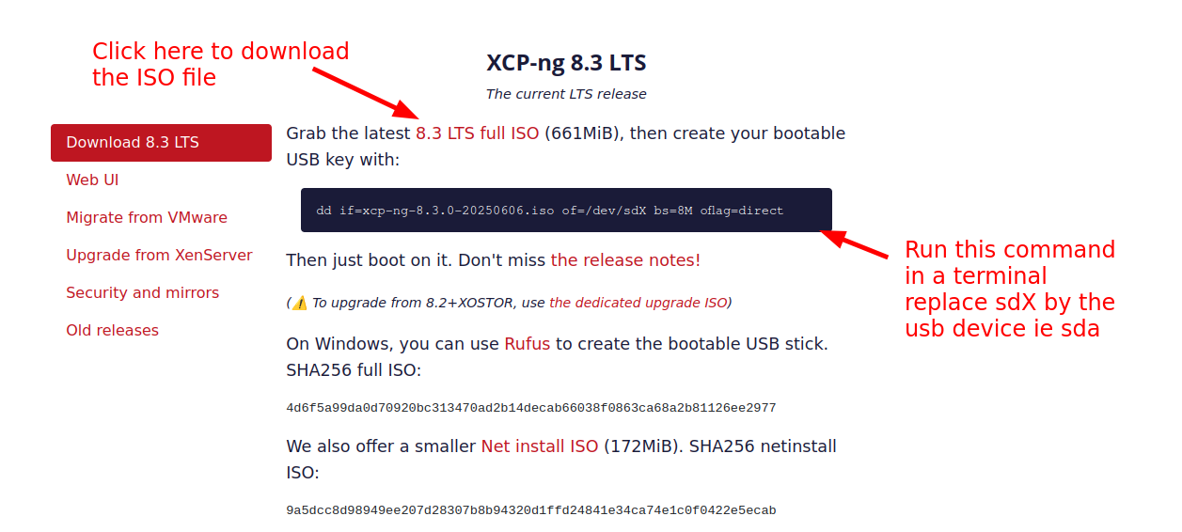
Once the image has been downloaded, if your Linux distribution doesn’t mount automatically your USB key ( which is good for a security stand point ), in a terminal run “sudo dmesg -Tw” then plug your usb stick.
With this command you will see on which device your usb stick has been detected.
You can stop dmesg with the shortcut key “Ctrl + c”, you will then return to the terminal prompt.
If your USB key has been automatically mounted, un-mount it with the command “eject” for example if your USB has been mounted in the /media folder, you can do “eject /media”
!!!After the next step everything on the USB will be erased.!!!
The command has been provided by the XCP-ng team I put it here again for ease.
“sudo dd if=xcp-ng-8.3.0-20250606.iso of=/dev/sdX bs=8M oflag=direct “
Double check your sdX to avoid erasing the wrong device, again the X should be replaced with the letter your have seen showing up in the dmesg.
Wait for the copy to finish, it may take sometimes depending on the performance of the USB key.

XCP-ng terminal
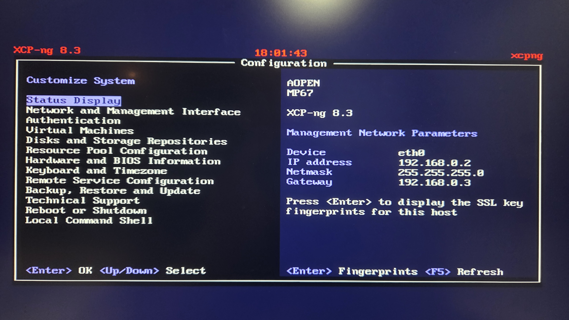

XO lite
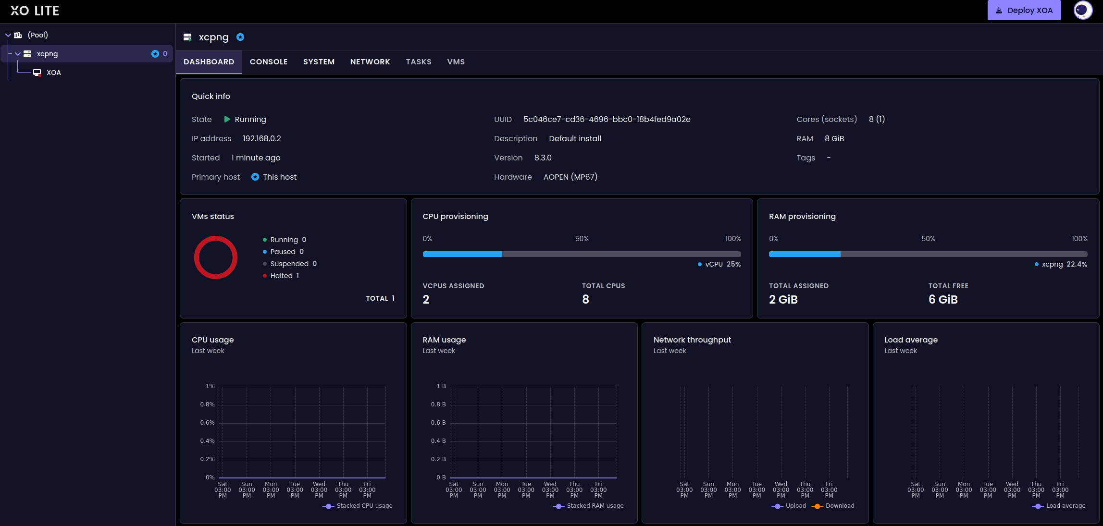

Deploy XOA
